**Fabric and Window Treatments**

**IDEC 1045**

**Week 2 Types of Fibers**

1. Replace the highlighted areas above.
2. Fill in the cells on the right in the table below.

## Week at a Glance

|  |  |
| --- | --- |
| **Week at a Glance** | |
| This week’s course learning outcomes (number and text) | **CLO01** Outline the basic natural and synthetic fibre history, production processes and uses in fabrics today |
| This week’s unit learning outcomes (number and text) | **Unit 1:** Types of Fibers  1.1 Examine natural fibers such as cotton, linen, silk and wool to understand how they are made and applied to drapery materials.  1.2 Examine synthetic fibers such as nylon, rayon and polyester and others to understand how they are made and applied to drapery materials. |
|  | |
| This week’s problem | This week’s problem is to introduce the student to the history of fabric and where they come from. We will learn how natural and synthetic fibers are made to be able to appreciate what goes into producing the materials we use today for window treatment cloth. |
| How does this week’s problem fit into the course so far? | This is the first lesson about fabrics that will give the student an understanding of the complex history and importance of fabric in society, understand how much work goes into creating different natural and synthetic fibers and understand |
| List of topics and subtopics that will be covered to address this week’s problem |  |
| If this is a hybrid course, what topics and activities will be covered in-class to support the online content? |  |
| How does problem fit into the remaining weeks of the course? | This is the groundwork to all future lessons in the course |
|  | |
| Graded Assessment? | Yes. Fill out the Evaluation section below.  No. |

## Introduction

|  |  |
| --- | --- |
| **Introduction to Week** | |
| Introduction | Description of content for this week:   * Explain what the user will learn * Describe the problem the user will be able to solve by the end of week * Answer the question “What’s in it for me (the learner)?”   This week is an introduction to Natural and Synthetic fibers to understand a bit of their history and how they are made. We need to understand where our fabrics come from and how they are produced to appreciate what goes into making them in today’s society. The manufacturing process is an interesting one to learn about and to see the long history of fabric use in the world. |
| Learning Outcomes | Write out the week’s unit learning outcomes here (number and text).  **Unit 1:** Types of Fibers  1.1 Examine natural fibers such as cotton, linen, silk and wool to understand how they are made and applied to drapery materials.  1.2 Examine synthetic fibers such as nylon, rayon and polyester and others to understand how they are made and applied to drapery materials.  **Text:** Designing Interiors 2nd pages 411-412 |
| Other relevant announcements/ reminders | Insert notes on assignments and/or anything out of the ordinary.  Note: You can also add an image here for a front cover page look and feel.  C:\Users\Linda\Downloads\172626346.jpg  Istock id: 172626346 |

****************** Beginning of instructional content ************************

# Types of Fibers

Most of us have no understanding of where the fabric that we use every day for our clothing, household items, upholstery and window treatments come from. We take for granted the numerous selection of fabrics available to use without thinking of how they are made and from what kind of materials they stem from. This week we will look at a brief history of natural and synthetic fibers and how they are made to learn about what goes into the kinds of materials you used daily in your home called textiles.

Textiles have been used for centuries all over the world for clothing, carpet, Drapery and Upholstery. They add an aesthetic quality to all homes and individuals.

## What is a fiber (fibre)?

A fiber is a raw material that is the building block of fabric. It is basically a long thin flexible strand of thread of material that is about 100 times longer than it is wide. We use fibers that are twisted together into what is called a **yarn** to weave or knit the threads together to make a cloth. The number of **ply** (The number of fibres added together)determines how loose or tight the weave is resulting in different products.

The amount of twist in a yarn determines its strength. No twist is a soft week yarn and the more twist in the yarn, the stronger and harder the yarn becomes.

Istock id: 614149922

Notice the yarn at the top with no twist would be weak while the increasing twists in the other examples will increase the strength of the yarn.

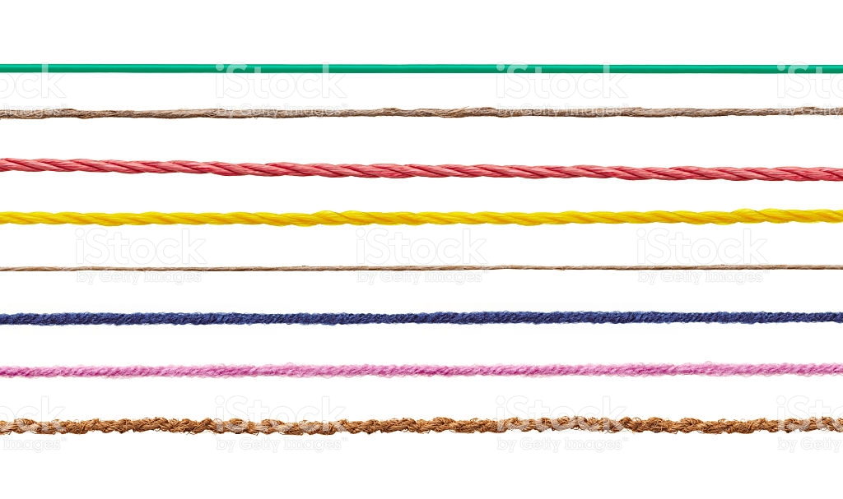

To make a fabric it is woven on a loom using interlacing use of **warp** (yarn run lengthwise) and yarn at right angles called a **weft** (yarn running across the width). They are woven on looms and here are many styles to produce and create different fabric weaves.

Istock id: 507424784

In this photo the vertical yarn is the warp and the horizontal yarn is the weft.

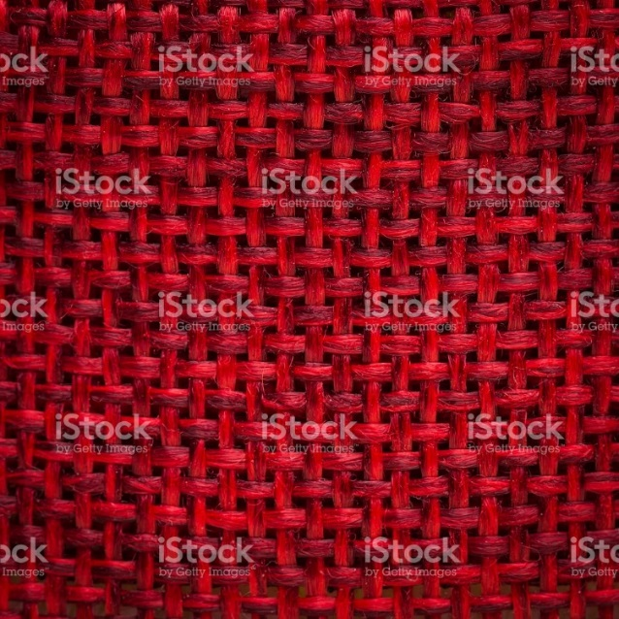

Check out this site to explain warp and weft… <https://en.wikipedia.org/wiki/Talk:Warp_and_woof>

Where to fibers come from? There are 2 basic kinds of fibers that are made for our use which are Natural and Synthetic. We will look at each and discover where they come from and how they are made.

## Natural Fibers

Natural fibers are from plant or animal origin. Animal coats are used such as sheep, goats, rabbits, alpacas and llama. Silk worm cocoons produce silk and plants and seeds produce Cotton. Leaves and stems such as flax come from the stalk of a plant to produce linen, Hemp, Ramie, Jute and Sisal.

Natural fibers are biodegradable over time and are called hydrophilic or absorbent. All natural fibers (other than silk) are known as **staple** fibers that have short lengths in inches. These short staple fibers need combing or carding to straighten before spinning.

**NOTE:** You will not be tested on the manufacturing process of the different kinds of fiber. That information is provided so you can appreciate what goes into making these kinds of materials.

### Cotton

This is a photo of cotton in the field ready for harvest. Istock photo ID: 522556574

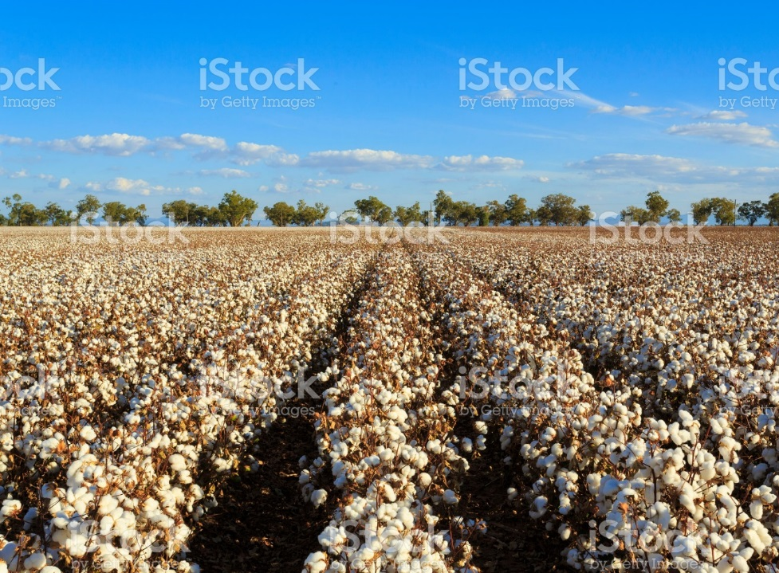

Cotton grows in the wild in many places on earth. Shreds of cloth or references in writing to cotton can be found dating back at least 7,000 years. The oldest discovery was found in a Mexican cave.

It is thought that the earliest cultivation of cotton was done in India. In the Mediterranean farmers in the 14th century cultivated cotton and shipped it to the Netherlands for spinning and weaving. Indigenous natives in Americas cultivated cotton in the 1500’s.

Cloth was so important centuries ago that in the 1700’s England had a law against the import or manufacturing of cloth made of cotton! This was because England had a strong wool industry and did not want the competition however by the later part of the 1700’s there were some British innovations like water powered spinning machines that were a vast improvement over hand-spinning and then cotton became a huge industry in England.

Look up <https://en.wikipedia.org/wiki/History_of_cotton> to read more about the history of cotton.

Basic cotton production has several steps; Cleaning, carding, spinning and weaving. Once the cotton is picked from the field it is placed in raw bales that weigh just under 500 pounds each. It is then taken to manufacturing mills that make the raw cotton into fabric.

This is what a bale of raw cotton looks like… I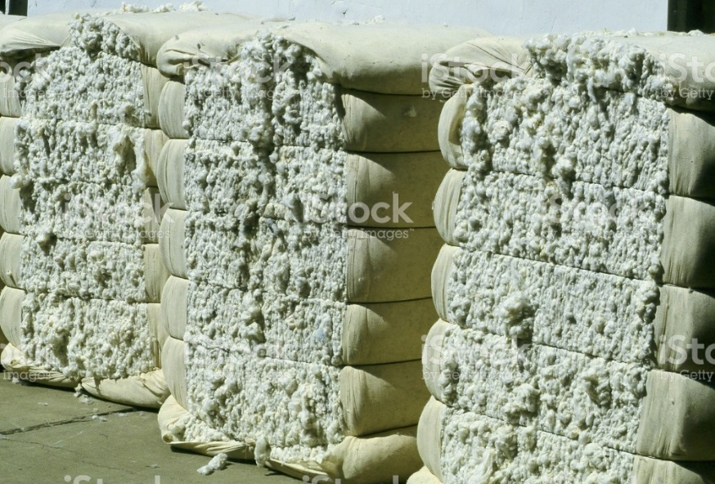Istock

Istock id: 139990758

**Cleaning:** In the first step of cleaning the cotton balls are vacuumed into tubes and carried to a dryer to reduce the moisture from the cotton and to improve the fiber quality. Cleaning removes the leaf trash, sticks and other foreign matter found when picked. It then goes to a machine called a cotton gin where the fibers are separated from the seeds. There are different kinds of gins to help pull away the seed.

**Carding:** Once the cleaning is done and the cotton is removed of debris the carding takes place. This process is like combing that pulls the fibers parallel to form a thin web. This can be done by hand or machine.

When using modern machines with high speed equipment the wire tooth rollers eventually create a continuous untwisted rope-like strand called a **sliver** (pronounced slyver).

This is what a sliver looks like. Istock id: 490439628 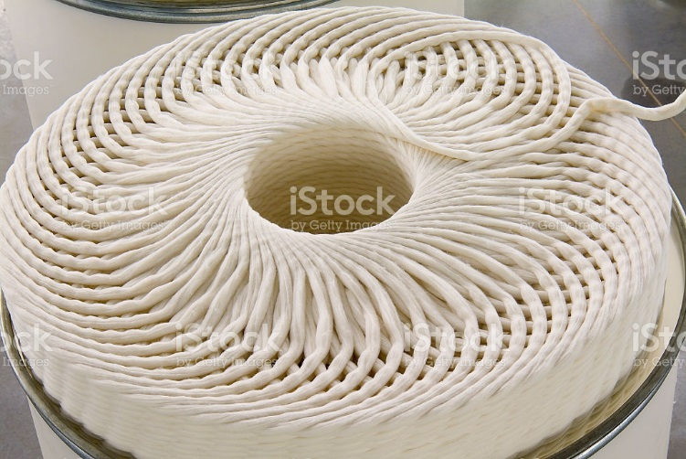

**Spinning:** The next process is spinning when the sliver is drawn out to a thinner stand giving a slight twist to improve its strength and is wound on large bobbins ready for the spinning. In the spinning process itself it is drawn and twisted into a yarn and placed on bobbins called roving bobbins.

**Weaving**: Lastly the yarn is woven into a fabric on weaving looms. Sometimes the fabric is coated with a starch mixture called sizing that will add strength for weaving by the large machines.

Woven cloth is called **greige or grey** as it is whitish but is still the natural yellow tint of the cotton ball. The cloth is treated further to improve its appearance by being bleached or dyed or prints added to produce fabric for retail sales and uses.

Cotton today is one of the most versatile materials that comes in many weights from very heavy weight to sheer. Prices can also go from high to low depending on the quality and durability of the fabric. Cotton is used in all areas of the home from window treatments to upholstery to carpets and clothing. With the trend to renewable resources, cotton is becoming even more popular as are all natural fibers.

See your text page 412 for advantages and disadvantages of this kind of fiber. It is common to mix cotton with other fiber combinations to increase its strength and durability. People like cotton because it will breathe and is comfortable to wear for example on hot summer days.

Watch this interesting video on the manufacturing of cotton…

Field to fabric video from the National Cotton Council: <https://www.youtube.com/watch?v=0hoHvN289Xs>

Ok to use…as per James Yochem…the LRC might be able to get permission to cc the video

### Linen

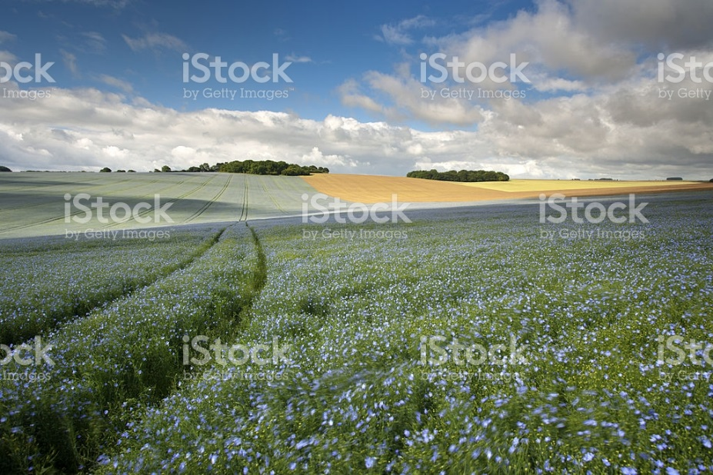

Istock id: 183808418

Linen is made from flax which is a tall, reed-like plant that grows similar to wheat. It is a temperamental plant to grow and the quality of the linen depends on the quality of the plant flax fibers found in the stalk. This is an expensive fabric to manufacture.

Flax is grown in many parts of the world with the top quality coming from Western Europe though recently the bulk of linen has moved to Eastern Europe and China. High quality linens are famously known from Ireland, Italy, and Belgium.

Linen was one of the earliest fibers made into string and cloth. Many centuries ago almost every family grew flax that they wove to linen for their own use. Some of the earliest established linen industry records date back 4,000 years ago from Egypt. Linen was being spun and woven 5,000 years B.C. even before wool. The Egyptians used linen for burial shrouds, and for centuries linen was used for table cloths, bed coverings and clothing.

In the first millennium B.C. the Egyptians mostly wore linen while the Greeks and Western Asians and Germans mostly wore wool. By the Roman period many linen tunics for comfort with wool robes over them for warmth. This trend continued to be common and eventually “linen” got to mean something like “underwear”. Our word “lingerie” is related to linen.

Basic linen production has 5 steps from cultivation, harvesting, ripping and retting, scotching and spinning.

**Cultivation** is using the long fibers to make linen yarn from the stalk of the flax plant. Growing takes 100 days from seed to harvest. The plant produces blue or white flowers on slender stalks that grow from 2-4 feet high. The plants with the blue flowers produce the finest fibers.

**Harvest** quality depends on the growing and harvesting techniques. As soon as the stalk turns yellow and the leaves wither the harvest begins. To wait longer reduces the luster of the fiber.

This is a field of flax being harvested. Istock id: 601940408

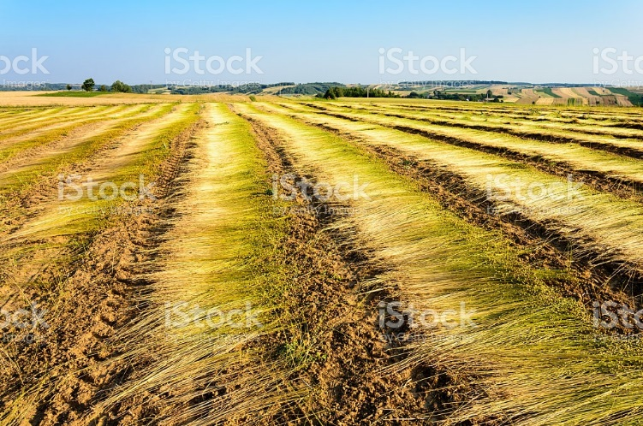

**Ripping and Retting** is done when the bundled plants go to manufacturing. Machines with course combs remove the seeds and leaves without damaging the stalks. The stalks are then retted where they are soaked in water and acids or other chemicals to remove dissolve the woody bark surrounding the fibers which can take up to 48 hours. This must be done properly or the quality of the yarn is weakened.

**Scutching** removes the woody portion of the stalks by crushing them between two metal rollers to separate the parts of the stalk. It is then squeezed and dried as they pass through rollers of the braking machine. It crushed the stalks and snaps them into small pieces called shives. Paddles are used to extract the fibers and another machine combs and straightens the fibers and separates long from short lengths.

**Spinning** takes the long fibers which are about 12-20 inches long called line or dressed flax to yield the finest yarn. Short fibers are called tow and make courser yarn. A spreading machine arranges the fibers of the same length into parallel lengths called slivers and then rollers press the slivers into rovings that resemble long lengths of hair. From here the rovings go to the spinning frame which draws out a few fibers at a time, twisting them to make the yarn strong. The fibers are then spun on a spindle into linen thread. This thread can be spun from course to very fine.

Linen can be woven or knitted into linen textiles that can be bleached, dyed, printed or finished with a number of treatments. It is an elegant as well as durable fiber that is the strongest of the vegetable fibers and 2-3 times stronger than cotton. It has a natural luster due to the wax content of the plant and is crisper and more lustrous than cotton. It has excellent “hang” in drapery and resists dirt and stains. This fabric is very absorbent and can gain up to 20% moisture without feeling damp. It does have a tendency to wrinkle which is part of the fabrics charm.

No video to be used

### Wool

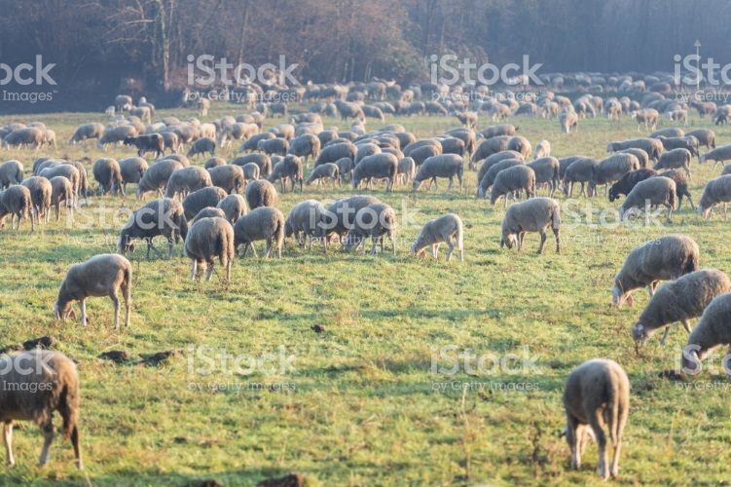 Istock id: 639881670

Wool is the dense warm coat usually from sheep and is also known as fleece. This fleece can come from llamas, goats and camels as well.

Anthropologists believe the use of wool came from the need to survive. In the Neolithic age about 8,000 BC people wore pelts as clothing to keep warm and by 4,000BC people were wearing wool clothing crudely made of woven fabric. By this time herds of wool making animals began to develop.

The first wool factory in England was in 50AD in Winchester by the Romans. Wool was recognized as one of the most practical fabrics to keep warm and by the 11th and 12th century there was a prospering wool trade. The English became expert at raising sheep and the Flemish were expert at the processing of it. As a result, the English sold the wool to the Flemish who processed the raw material and re-sold it back to the English to make fabric. Britain made laws to stimulate the domestic production of wool and resulted in Judges, professors and students wearing robes made of English wool. Even today English judges and others wear wool wigs. Competition with the American colonies resulted in the English passing laws to protect their “golden fleece”. One law even threatened the amputation of a hand if a colonist tried to improve the blood line of American sheep.

In 1797 the British brought 13 Merino sheep to Australia and started that countries Merino sheep industry. Australia was a colony of the British and they used the island to send prisoners from the overcrowded prison system and some settlers also went there. Since them Australia has become famous for their sheep and wool industry. Other major producers are New Zealand, USA, Argentine, China and South Africa. Australia is still the leading supplier producing 25% of the world production. Cotton is the #1 fiber that is plant based and wool the #1 fiber from animals.

In scientific terms woos is a protein called keratin. There are about 40 different breeds of sheep and around 200 types of wool in today’s global industry.

Wool is comprised of an outer layer of scales that are similar to fish scales called a **cuticle.** The inner structure is called the **cortex** that comprises of millions of cigar shape cells that crimp in the wool fiber. <https://www.sciencelearn.org.nz/resources/875-wool-fibre-properties>

There are several steps to wool production from Raw materials, shearing, grading and sorting, cleaning and scouring, carding, and spinning.

**Raw materials** are the sheep themselves. Wool is sheared from sheep that is dirty and full of burs, grease and perspiration. About 2/3 of the weight of sheared wool may be dirt and grease. The fleece from one sheep can weigh from 6-18 pounds.

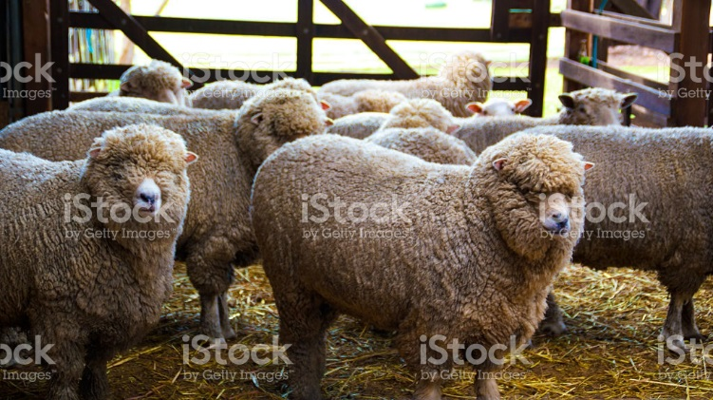

Istock id: 496980176

**Shearing** the sheep is often done by hand, however computer controlled machines can clip fleece with robot like arms. An experienced shearer can sheer up to 200 sheep per day and still keep the fleece in one piece.

Before processing the fleece it goes through the process of **grading and sorting** by being broken up according to quality. The shoulders and sides are the highest quality of wool. The fleece of lower legs have a lesser quality. During this stage stained, damaged or inferior wool is removed and the rest is sorted according to the fibers quality. Wool fibers are judged on strength and diameter as well as waviness and colour.

During the **cleaning and scouring** steps, the wool is scoured with detergents to remove the impurities. This creates what is called “raw” or “greased” wool that still contains dirt, sweat and contaminants that make wool heavy. To remove this the wool is placed in a bath of alkaline bath of soap, water and soda ash. During this process it also produces lanolin which is saved and used for other produces. To wash the wool it is swished back and forth with wooden forks that beat it before it goes to rollers that pass from one tank to another. In the end it is beaten into a fluffy mass which his squeezed out. Some of the oil is put back to make it more manageable.

The fibers are then **carded** that straighten and blend the fibers into slivers by a metal teethed machine. This process also removes the last of the dirt in the wool. The wool is passed through rollers with wire teeth that untangle the fibers and arrange them into a flat sheet called a web.

This photo is an example of wool that has been cleaned and carded.

Istock id: 478533702

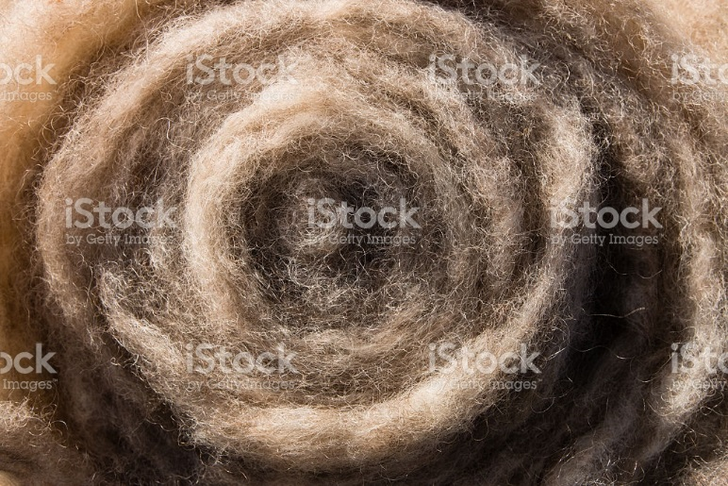

The web is then formed into narrow ropes knows as slivers.

After this stage comes **spinning** where the fibers are formed together to make yarn strands that are spun around cones or bobbins. This stage prepares the wool for weaving into cloth.

**Lamb’s wool** is fleece from young sheep before the age of 8 months old and has a softer feel.

**Virgin wool** has never been processed in any manner before in manufacturing.

Much of the wool we use in the world is recycled and used again. If only new wool was used, there would not be enough wool to meet the world demand. Lamb’s wool and virgin wool explain why some wool is so expensive.

**Woolen yarn** feels soft and fuzzy and is heavier than **worsted wool** which is lighter and has a high twill twist. It is smoother than and not as bulky as woolen wool. Worsted wool is arranged parallel using longer yarn. Worsted wool is more durable and costly than woolens.

This website shows the different looks between the two:

[www.hilltopcloud.co.uk/blog/woolen-vs-worsted](http://www.hilltopcloud.co.uk/blog/woolen-vs-worsted)

Wool can be dyed at various stages of manufacturing and can be knitted or woven into a variety of fabrics. This is a durable fabric with good elasticity. It resists soiling and provides great insulation.

Check out this website for more information on wool: <https://en.wikipedia.org/wiki/Wool>

This is a video about wool production… Ok to use as per James Yochem

<https://www.youtube.com/watch?v=yafkK0uk65U>

### Silk

Istock id: 506900188

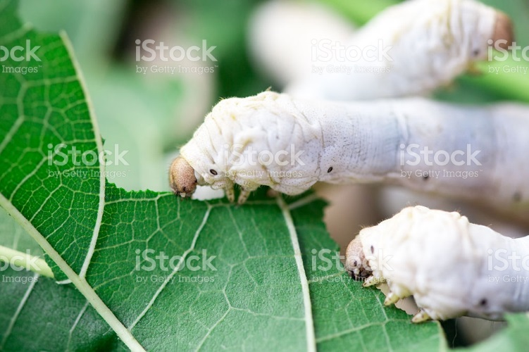

Silk is considered a luxury fabric that is made from the larva of the silk worm creating a cocoon. It is a protein fiber like wool.

The making of silk also called sericulture, has a long history dating back several thousand years. It was invented and perfected by the Chinese who kept the process secret for many centuries and punishment was death to anyone trying to smuggle the secrets of sericulture out of China.

Silk was traded for centuries between China and Europe over the “Silk Road”.

Check out this website about the Silk Road… <https://en.wikipedia.org/wiki/Silk_Road>

Today silk production occurs in several other countries including Japan, India and Italy and yet China still produces more than 60% of the world production and are considered masters of silk.

There are several steps to silk production which include the eggs, the worm, the cocoon, sorting, immersions, reeling and unwinding and baling.

Silk production begins with the moth lying about 500 **eggs** in 4-6 days and then dies. The only purpose of the moth is to lay eggs what will produce the next generation of silkworms.

The eggs are so tiny that the 500 eggs weigh under two ounces. It takes 30,000 silk worms to produce twelve pounds of raw silk.

The **silk worm** feeds on mulberry leaves and form a covering around it by secreting a protein like substance through its head. This covering becomes the cocoon. Silk **filaments** are long continuous strands that can be measured in yards or even miles long. Cultivated silk filaments have a higher luster, are smoother and more even than wild silk. They can be cut shorted to blend with other kinds of materials like synthetics.

Istock id: 183283991

This photo shows cultivated silk worms creating cocoons.

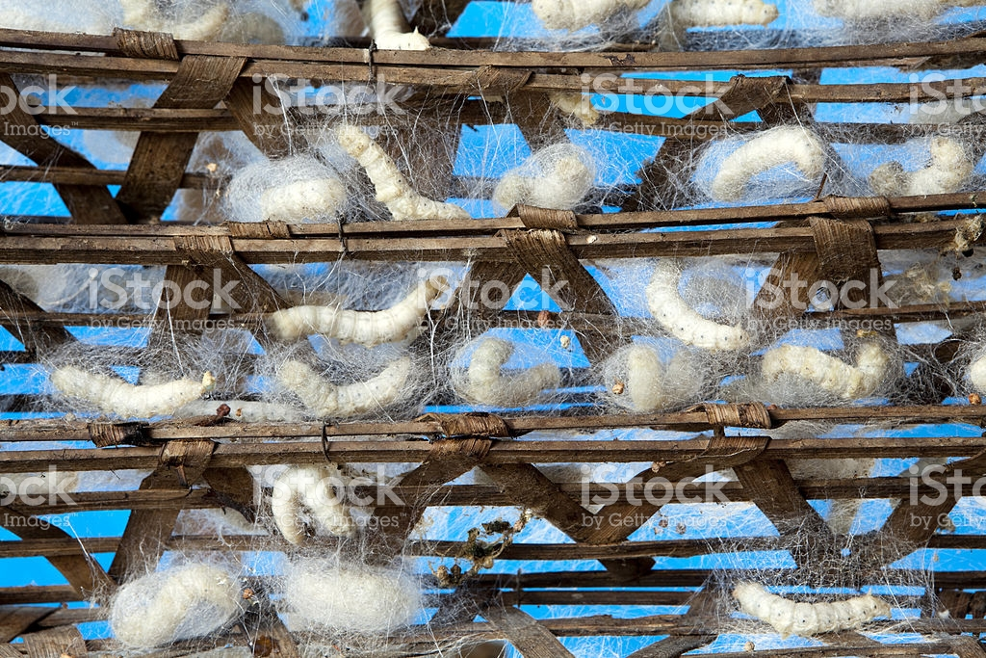

The most special kind of silkworm is called the Bombyx Mori moth. There are other commercial varieties of natural silk however most of the supply is from the Bombyx Mori moth which is domesticated. The other varieties are known as wild silk that grow in remote forests and under natural conditions.

**Tussah silk** is wild silk that is uneven and less lustrous and more course than **cultivated silk** (domestic)which is long. With Tussah silk you will see slubs where the shorter filament has been tied together and look like tiny bumps while cultivated silk is smooth.

The **cocoons** are raised by the farmer and delivered to the factory. These cocoons are **sorted** by colour, size, shape and texture that determine the quality of the silk. Colours can range from white and yellow to grayish tones.

Istock id: 161818315

These are silk cocoons sorted into colour and quality

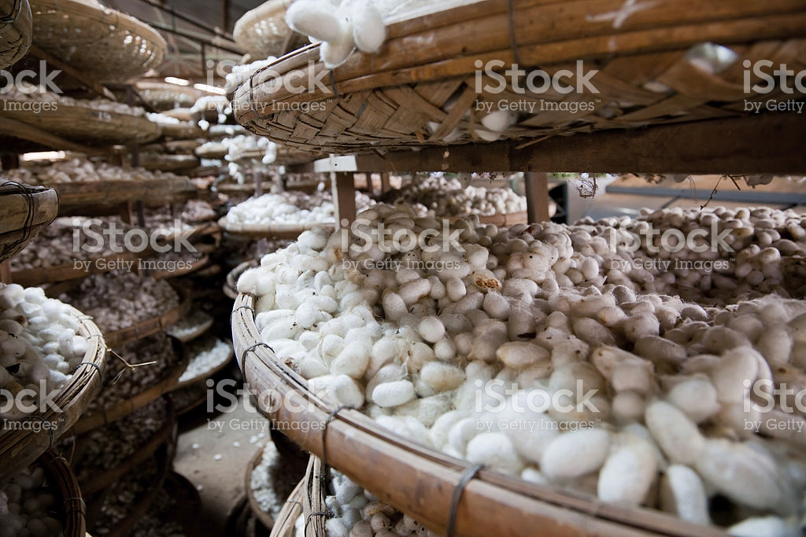

The next step is a series of hot and cold **immersions** that soften the cocoon and allows the filament to be unwound as one continuous thread. **Reeling** is the process of unwinding the filaments and combing them to make a thread that is called raw silk. It takes 3-10 strands to make one thread of silk and can be up to 600 yards long.

Istock id: 469894133 Photo shows the filament being released from the cocoon.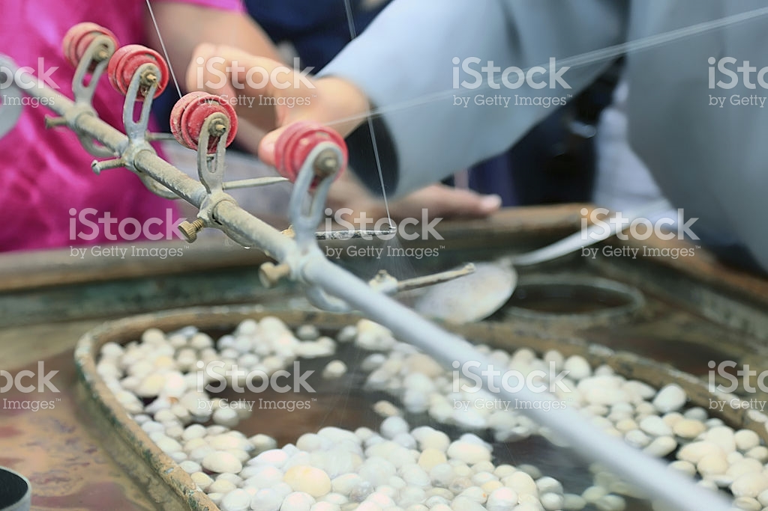

These strands are packed into small bundles that are from 4-6 pounds called books. The books are then put into **bales** that weigh about 130 pounds and shipped to textile mills all over the world.

Silk has a very strong tensile strength meaning that it can withstand a lot of pulling type pressure without breaking. This is not to be confused with durability or abrasion resistance as silk will not stand up to heavy wear like other fibers is easily damaged by sunlight. It dyes easily and has good colour retention. It has excellent hang on drapery with great sheen and an elegant look. A great deal of silk cloth is used for clothing, light upholstery use, carpeting and window treatments.

Photo by Linda Guthro

This silk valance shows the texture and sheen that silk offers.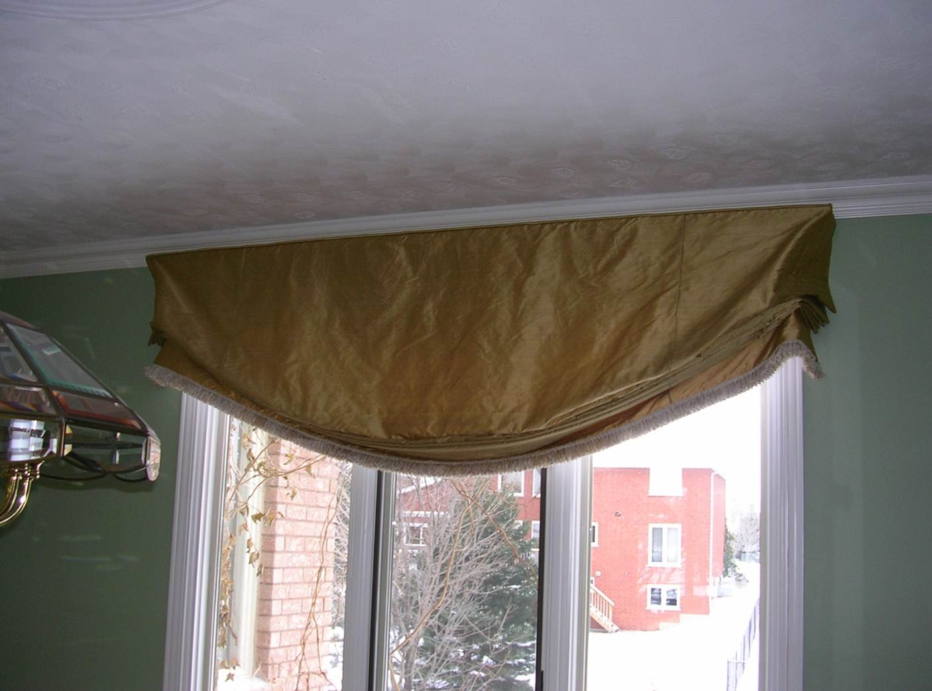

**INTERESETING NOTE:** I had a client who had a bad previous experience with silk roman shades. Within 6 months of installation they had all rotted at the fold lines of the shade! This was the fault of the previous person who ordered them for her because she did not use the correct lining with the silk to prevent the sun from reaching the silk. It is important for any decorator to know about the pros and cons of materials to create a quality treatment for every client. When I had her silk treatments made I was sure to protect the silk from the sun and she has had them now for several years with no damage. I will explain what I did to protect the silk in a future lesson.

Silk can have many different appearances and can look like cotton or synthetic.

**Dupioni silk** is made from a cocoon of two silk worms being nested together. The luster of the thread shimmers and changes colour in the light. In spinning the double strand is not separated giving this effect.

This is an interesting video about silk production. Ok as per James Yochem

https://www.youtube.com/watch?v=77ktNSPFbwQ

### Other natural fibers

Natural fibers are gaining popularity as they are a renewable resource. While the ones we have already talked about there are some others gaining in popularity.

**Hemp** is a grass that is made from a species of cannabis sativa which is a high yield crop. It can produce much more fiber per acre than cotton or flax. It is stronger than cotton, hypo-allergenic and has the look and feel of linen. I will soften with age and will wrinkle but is not colour fast.

**Bamboo** is also a grass that has a strong fiber and grows quickly. Sometimes harsh chemicals are needed to breakdown the stalk. In some areas of the world it is close to extinction due to the high demand. It is used for household items, flooring and window treatments.

**Soy** is a by-product of the soybean oil production. It is renewable and biodegradable generally made from the waste of tofu and soy oil plants. It is soft and durable with silk like properties. It can be warmer than wool and easy to care for. It is used in clothing and carries a premium cost among the eco-label fabrics.

## Synthetic fibers

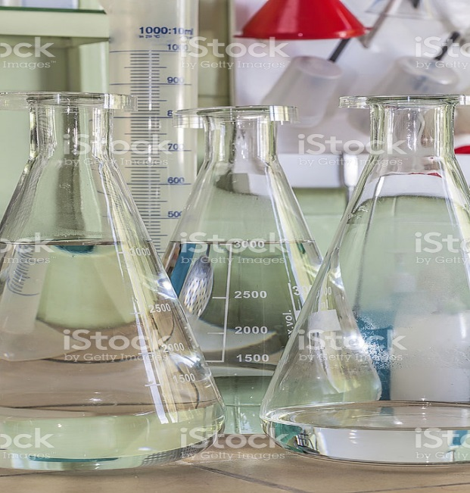 Istock id: 181495106

Historically only natural fibers were used and all had their limitations. The finest grades had high performance records but the majority were made with much lower standards of cloth and were often uncomfortable and wore out quickly.

The supply depended on uncontrollable factors like disease, weather and war that impacted the supply. In the 1800’s scientists began to research artificial silk to try and produce a man-made fiber that could be made more dependably.

In 1855 a Swiss chemist named Audemars got a patent in England for an artificial silk. He dissolved the inner bark of the mulberry tree and chemically modified it to produce cellulose. Another chemist named Swan experimented by forcing cellulose liquid through fine holes into a coagulating bath. This worked similar to the carbon filament used in Edison’s invention of the filament light bulb. He could use the same process to make textiles. In 1855 he exhibited some of these fabrics in London and received great interest though none were ready for sale at this time.

The first commercial fiber was shown at the 1889 Paris exhibition showing artificial silk and two years later the first commercial Rayon plant was opened in France. In the United States by 1910 the American Viscose Company was formed to make Rayon. DuPont was a chemist who discovered in his laboratory how to make nylon and he transformed common materials like wood, coal, air and water into fibers. By the mid 1920’s Rayon was about 50% cheaper than natural fibers like silk and established the basics for the discovery of a new world of manufactured fibers called synthetics.

Nylon was the first true synthetic fiber and DuPont began its production in 1939.

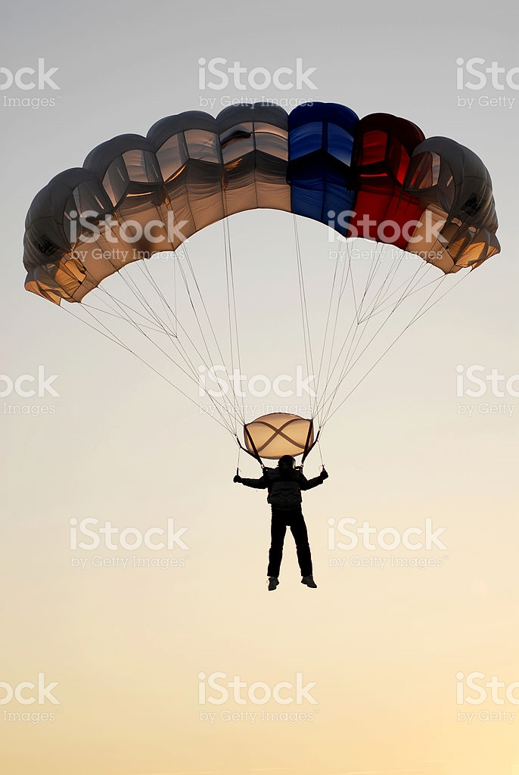Istock id: 117360950

Parachutes are made from nylon

The first nylon stockings were shown that year at the San Francisco Exposition and the first nylon product was the toothbrush. Parachutes previously made of silk were now produced out of nylon for WW2. By the 1950’s man-made materials made up about of 20% of fiber needs in textile mills.

There are two types of manufactured fibers called Regenerated (man-made) and Synthetic.

**Regenerated** are made from natural materials by processing to a fiber called cellulosic or semi-synthetic. These fibers are re-generated from cellulose in cotton and wood pulp such as Rayon and Acetate. **Cellulosic fibers** are **Organic** meaning that they are natural materials that are mixed with chemicals to produce a fiber. These natural materials are plant based had a life that grew from a seed to a plant.

**Non-cellulosic fibers** are **Inorganic** and are made from materials that never had a life so to speak such as Carbon, glass, metal and ceramic. These are considered true synthetics.

All synthetic fibers are converted to a liquid state and chemically converted to a fiber by being forced through spinnerets that look like a shower head to form a thread called extrusion.

They are then twisted to gain strength to form a fiber. The extrusion process can create different thickness called denier. **Denier** is a kind of measurement that determines the thickness of individual threads. A high denier count will be a thick fiber and a low denier count will be more sheer, soft or silky. Depending on the kind of fiber being created they can be produced in many different ways to give different end results. The fibers are then woven in many different ways to produce cloth. Today synthetics are about 50% of all fabric manufacturing. Natural and synthetic fibers are often combined to enhance their positive properties in a fabric.

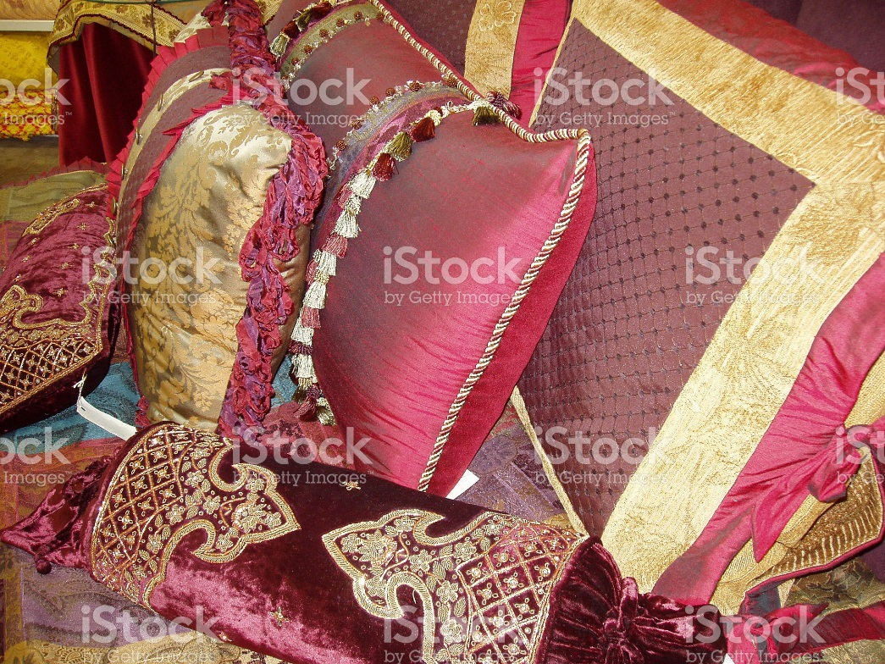

Istock id: 470995463

Popular synthetics today are Rayon, Acetate, Nylon, Olefin and Polyester.

**Rayon** is organic and made from cellulose of wood or cotton. It can be made to mimic natural fibers of cotton, silk, linen and wool. <https://en.wikipedia.org/wiki/Rayon>

**Acetate** is organic and made from wood pulp or cotton. It is one of the first synthetic fibers and first was produced into cellulose film for motion pictures. It has many similarities to rayon and is used often today for its good drape and to add sheen to other fiber content.

<https://en.wikipedia.org/wiki/Cellulose_acetate>

**Nylon** is inorganic and made from coal. It is used for its resiliency and good drape quality and colour retention. <https://en.wikipedia.org/wiki/Nylon>

**Olefin** is inorganic and made from carbon and hydrogen. It has a kind of waxy feel, is resistant to moisture, is stain resistant and has low static. <https://en.wikipedia.org/wiki/Olefin_fiber>

**Polyester** is inorganic and derives from chemicals. It is a strong versatile fiber that is often mixed with natural fibers to improve strength. <https://en.wikipedia.org/wiki/Polyester>

While synthetic fibers were originally made to be more affordable than natural fibers, today this is not the case. Some synthetics can be less expensive but with the development and refinement of the manufacturing process they may not be any less expensive than natural fibers today. Some polyester can look and feel exactly like silk for example but has benefits of not being as sensitive to sunlight and can be washable which contributes to the cost.

**INTERESTING NOTE:** Many times I have given my seamstress a polyester fabric that looks like silk and she cannot tell the difference. She has been in the industry for over 40 years and cannot tell any longer the difference between real and synthetic silk. She calls me to check the fabric content for sun protection. This shows how far synthetics have come that can fool an expert like my seamstress! I will use a polyester silk for families with busy lifestyles and small children so that the fabric can be easily washed and stand up to heavy use.

This website offers a good explanation of synthetic fibers… <https://en.wikipedia.org/wiki/Synthetic_fiber>

This video explains the basics of synthetic production to produce nylon …LRC might be able to get permission to cc the video as per James Yochem

<https://www.youtube.com/watch?v=y479OXBzCBQ>

## Conclusion:

You have a lot of information about both natural and synthetic fabrics from this week’s lesson. I hope you found it interesting to understand how we create fabrics from these raw materials. We often do not think of where our fabrics come from and take them for granted. Knowing more about them from this lesson will give you an appreciation for what goes into making a certain kind of fabric and how we use them. You may have even had a surprise or two about some of the fabric sources and processes. I know I did when I first learned about them. Next week we will continue our education on this interesting topic.

I would like to add a discussion forum for this week with questions like these…

What have you found most interesting or surprising about Natural and synthetic fibers? Do you feel the manufacturing process justifies the cost of the end materials?

NOTE: I am checking with James Yokem to make sure the videos are okay to use and will find alternates if they are not suitable for copyright.

********************* End of instructional content *************************